Tranquility Care LLC.

Temporary Service Suspension Policy

I. Policy

It is the policy of this DHS licensed provider (program) to ensure our procedures for temporary service suspension promote continuity of care and service coordination for persons receiving services.

II. Procedures

- This program will limit temporary service suspension to the following situations:

- The person's conduct poses an imminent risk of physical harm to self or others and either:
  - positive support strategies have been implemented to resolve the issues leading to the temporary service suspension but have not been effective and additional positive support strategies would not achieve and maintain safety; or
  - less restrictive measures would not resolve the issues leading to the suspension; OR
- The person has emergent medical issues that exceed the license holder's ability to meet the person's needs; OR
- The program has not been paid for services.

- Prior to giving notice of temporary service suspension, the program must document actions taken to minimize or eliminate the need for service suspension.
- Action taken by the program must include, at a minimum:
  - Consultation with the person's support team or expanded support team to identify and resolve issues leading to issuance of the notice; and
  - A request to the case manager for intervention services identified, including behavioral support services, in-home or out-of-home crisis respite services, specialist services, or other professional consultation or intervention services to support the person in the program.
- If, based on the best interests of the person, the circumstances at the time of the notice were such that the program unable to consult with the person’s team or request interventions services, the program must document the specific circumstances and the reason for being unable to do so.

- The notice of temporary service suspension must meet the following requirements:

- This program must notify the person or the person’s legal representative and the case manager in writing of the intended temporary service suspension.
- If the temporary service suspension is from residential supports and services, including supported living services, foster care services, or residential services in a supervised living facility, including and ICF/DD, the program must also notify the Commissioner in writing. DHS notification will be provided by fax at 651-431-7406.
- Notice of temporary service suspension must be given on the first day of the service suspension.
- The written notice service suspension must include the following elements:
- The reason for the action;
- A summary of actions taken to minimize or eliminate the need for temporary service suspension; and
- Why these measures failed to prevent the suspension.
- During the temporary suspension period the program must:
  - Provide information requested by the person or case manager;
  - Work with the support team or expanded support team to develop reasonable alternatives to protect the person and others and to support continuity of care; and
  - Maintain information about the service suspension, including the written notice of temporary service suspension in the person’s record.

- A person has the right to return to receiving services during or following a service suspension with the following conditions.

- Based on a review by the person’s support team or expanded support team, the person no longer poses an imminent risk of physical harm to self or others, the person has a right to return to receiving services.
- If, at the time of the service suspension or at any time during the suspension, the person is receiving treatment related to the conduct that resulted in the service suspension, the support team or expanded support team must consider the recommendation of the licensed health professional, mental health professional, or other licensed professional involved in the person's care or treatment when determining whether the person no longer poses an imminent risk of physical harm to self or others and can return to the program.
- If the support team or expanded support team makes a determination that is contrary to the recommendation of a licensed professional treating the person, the program must document the specific reasons why a contrary decision was made.

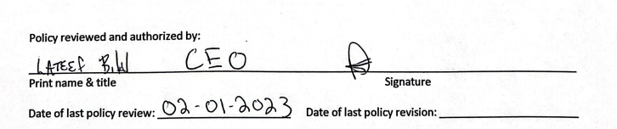

Legal Authority: MS § 245D.10, subd. 3

