TRANQUILITY CARE LLC.

Universal Precautions and Sanitary Practices Policy
I. Policy

It is the policy of this DHS licensed provider (program) to follow universal precautions and sanitary practices, including hand washing, for infection prevention and control, and to prevent communicable diseases.

II. Procedures

- Universal precautions, sanitary practices, and prevention
Universal precautions apply to the following infectious materials: blood; bodily fluids visibly contaminated by blood; semen; and vaginal secretions. All staff are required to follow universal precautions and sanitary practices, including:
- Use of proper hand washing procedure
- Use of gloves in contact with infectious materials.
- Use of a gown or apron when clothing may become soiled with infectious materials
- Use of a mask and eye protection, if splashing is possible
- Use of gloves and disinfecting solution when cleaning a contaminated surface
- Proper disposal of sharps
- Use of gloves and proper bagging procedures when handling and washing contaminated laundry

- Control of communicable diseases (Reportable Infectious Diseases: Reportable Diseases A-Z - Minnesota Dept. of Health)(http://www.health.state.mn.us)
- Staff will report any signs of possible infections or symptoms of communicable diseases that a person receiving services is experiencing to the manager.
- When a person receiving services has been exposed to a diagnosed communicable disease, staff will promptly report to other licensed providers and residential settings.
- Staff diagnosed with a communicable disease, may return to work upon direction of a health care professional.

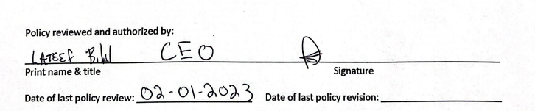

Legal Authority: MS §§ 245D.11, subd. 2 (1) and 245D.06, subd 2 (5)

NOTE: The website from the Minnesota Department of Health (MDH) is included as a resource for additional information.

