TRANQUILITY CARE LLC.

Drug and Alcohol Prohibition Policy

I. Policy
It is the policy of this DHS licensed provider (program) to support a workplace free from the effects of drugs, alcohol, chemicals, and abuse of prescription medications. This policy applies to all of our employees, subcontractors, and volunteers (employees).

II. Procedures
  - All employees must be free from the abuse of prescription medications or being in any manner under the influence of a chemical that impairs their ability to provide services or care.

  - The consumption of alcohol is prohibited while directly responsible for persons receiving services, or on our property (owned or leased), or in our vehicles, machinery, or equipment (owned or leased), and will result in corrective action up to and including termination.

  - Being under the influence of a controlled substance identified under Minnesota Statutes, chapter 152, or alcohol, or illegal drugs in any manner that impairs or could impair an employee’s ability to provide care or services to persons receiving services is prohibited and will result in corrective action up to and including termination.

  - The use, sale, manufacture, distribution, or possession of illegal drugs while providing care or to persons receiving services, or on our property (owned or leased), or in our vehicles, machinery, or equipment (owned or leased), will result in corrective action up to and including termination.

  - Any employee convicted of criminal drug use or activity must notify the manager no later than five (5) days after the conviction.

  - Criminal conviction for the sale of narcotics, illegal drugs or controlled substances will result in corrective action up to and including termination.

  - The program’s designated staff person will notify the appropriate law enforcement agency when we have reasonable suspicion to believe that an employee may have illegal drugs in his/her possession while on duty during work hours. Where appropriate, we will also notify licensing boards.
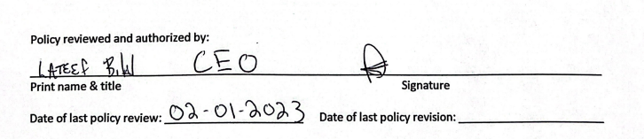

Legal Authority: MS §§ 245.04, subd. 1 (c) and 14

