Tranquility Care LLC.
Grievance Policy

Policy

It is the policy of this DHS licensed provider (program) to ensure that people served by this program have the right to respectful and responsive services. We are committed to providing a simple complaint process for the people served in our program and their authorized or legal representatives to bring grievances forward and have them resolved in a timely manner.

Procedures

- Service Initiation
A person receiving services and their case manager will be notified of this policy, and provided a copy, within five working days of service initiation.

- How to File a Grievance
- The person receiving services or person’s authorized or legal representative:
  - should talk to a staff person that they feel comfortable with about their complaint or problem;
  - clearly inform the staff person that they are filing a formal grievance and not just an informal complaint or problem; and
  - may request staff assistance in filing a grievance.
- If the person or person’s authorized or legal representative does not believe that their grievance has been resolved they may bring the complaint to the highest level of authority in this program.
- That person is: Lateef Bilal;
- They may be reached at:
  - [704 40th Ave NE Minneapolis UNIT 2, MN 55421]; and

  - [(612) 532-0584].

- Response by the Program
- Upon request, staff will provide assistance with the complaint process to the service recipient and their authorized representative. This assistance will include:
  - the name, address, and telephone number of outside agencies to assist the person; and
  - responding to the complaint in such a manner that the service recipient or authorized representative’s concerns are resolved.
- This program will respond promptly to grievances that affect the health and safety of service recipients.
- All other complaints will be responded to within 14 calendar days of the receipt of the complaint.
- All complaints will be resolved within 30 calendar days of the receipt.
- If the complaint is not resolved within 30 calendar days, this program will document the reason for the delay and a plan for resolution.
- Once a complaint is received, the program is required to complete a complaint review. The complaint review will include an evaluation of whether:
  - related policy and procedures were followed;
  - related policy and procedures were adequate;
  - there is a need for additional staff training;
  - the complaint is similar to past complaints with the persons, staff, or services involved; and
  - there is a need for corrective action by the license holder to protect the health and safety of persons receiving services.
- Based on this review, the license holder must develop, document, and implement a corrective action plan designed to correct current lapses and prevent future lapses in performance by staff or the license holder, if any.
- The program will provide a written summary of the complaint and a notice of the complaint resolution to the person and case manager that:
  - identifies the nature of the complaint and the date it was received;
  - includes the results of the complaint review; and
  - identifies the complaint resolution, including any corrective action.

D. The complaint summary and resolution notice must be maintained in the person’s record.

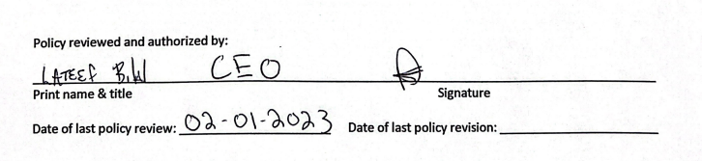

Legal Authority: Minn. Stat. § 245D.10, subd. 2 and 4

