Tranquility Care LLC.

Service Termination Policy
I. Policy

It is the policy of this DHS licensed provider (program) to ensure our procedures for service termination promote continuity of care and service coordination for persons receiving services.

II. Procedures

- This program must permit each person to remain in the program or to continue receiving services and must not terminate services unless:

- The termination is necessary for the person's welfare and the license holder cannot meet the person's needs;
- The safety of the person, others in the program, or staff in the program is endangered and positive support strategies were attempted and have not achieved and effectively maintained safety for the person or others;
- The health of the person, others in the program, or staff would otherwise be endangered;
- The license holder has not been paid for services;
- The program or license holder ceases to operate; or
- The person has been terminated by the lead agency from waiver eligibility.

- Prior to giving notice of service termination this program must document the actions taken to minimize or eliminate the need for termination notice.

- Action taken by the license holder must include, at a minimum:
  - Consultation with the person’s support team or expanded support team to identify and resolve issues leading to the issuance of the notice; and
  - A request to the case manager for intervention services, including behavioral support services, in-home or out-of-home crisis respite services, specialist services, or other professional consultation or intervention services to support the person in the program.

The request for intervention services will not be made for service termination notices issued because the program has not been paid for services.

- If, based on the best interests of the person, the circumstances at the time of the notice were such that the program unable to consult with the person’s team or request interventions services, the program must document the specific circumstances and the reason for being unable to do so.

- The notice of service termination must meet the following requirements:

- This program must notify the person or the person’s legal representative and the case manager in writing of the intended service termination.
- If the service termination is from residential supports and services, including supported living services, foster care services, or residential services in a supervised living facility, including an ICF/DD, the license holder must also notify the Department of Human Services in writing. DHS notification will be provided by fax at 651-431-7406.
- The written notice of a proposed service termination must include all of the following elements:
- The reason for the action;
- A summary of actions taken to minimize or eliminate the need for service termination or temporary service suspension, and why these measures failed to prevent the termination or suspension. A summary of actions is not required when service termination is a result of the when the program ceasing operation;
- The person's right to appeal the termination of services under Minnesota Statutes, section 256.045, subdivision 3, paragraph (a); and
- The person's right to seek a temporary order staying the termination of services according to the procedures in section 256.045, subdivision 4a or 6, paragraph (c).
- The written notice of a proposed service termination, including those situations which began with a temporary service suspension, must be given before the proposed effective date of service termination.
  - For those persons receiving intensive supports and services, the notice must be provided at least 60 days before the proposed effective date of service termination.
  - For those persons receiving other services, the notice must be provided at least 30 days before the proposed effective date of service termination.
- This notice may be given in conjunction with a notice of temporary service suspension.

- During the service termination notice period, the program must:

- Work with the support team or expanded support team to develop reasonable alternatives to protect the person and others and to support continuity of care;
- Provide information requested by the person or case manager; and
- Maintain information about the service termination, including the written notice of intended service termination, in the person’s record.

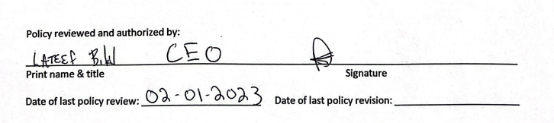

Legal Authority: MS § 245D.10, subd. 3a

